Agile Meetings Documentation
Agile methodology emphasizes regular communication, collaboration, and continuous improvement. Meetings in Agile are structured, time‑boxed events designed to keep the team aligned, productive, and focused on delivering value.

1. Daily Standup Meeting

Purpose
The Daily Standup is a short meeting held every day to synchronize team activities and identify any obstacles.

Duration
- 10–15 minutes (time‑boxed)

Participants
- Development Team
- Scrum Master
- Product Owner (optional)

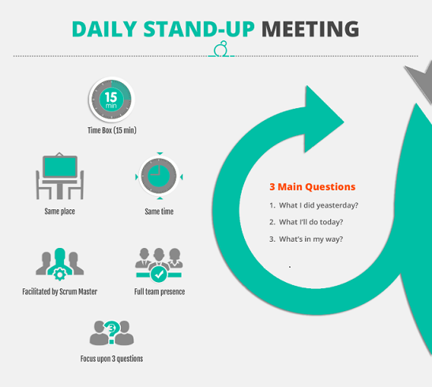

Key Questions
Each team member answers: 1. What did I work on yesterday? 2. What will I work on today? 3. Are there any blockers or issues?

Outcomes
- Clear understanding of daily progress
- Early identification of blockers
- Improved team coordination

2. Sprint Planning Meeting

Purpose
Sprint Planning defines the work to be completed during the upcoming sprint and how it will be achieved.

Duration
- Typically 2–4 hours (depending on sprint length)

Participants
- Product Owner
- Development Team
- Scrum Master

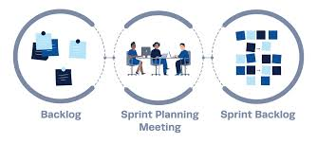

Activities
- Review product backlog items
- Select user stories for the sprint
- Define sprint goal
- Break stories into tasks and estimate effort

Outcomes
- A committed sprint backlog
- Clear sprint goal
- Shared understanding of priorities

3. Retrospective Meeting

Purpose
The Retrospective focuses on continuous improvement by reflecting on the completed sprint.

Duration
- 1–2 hours

Participants
- Development Team
- Scrum Master
- Product Owner (optional)

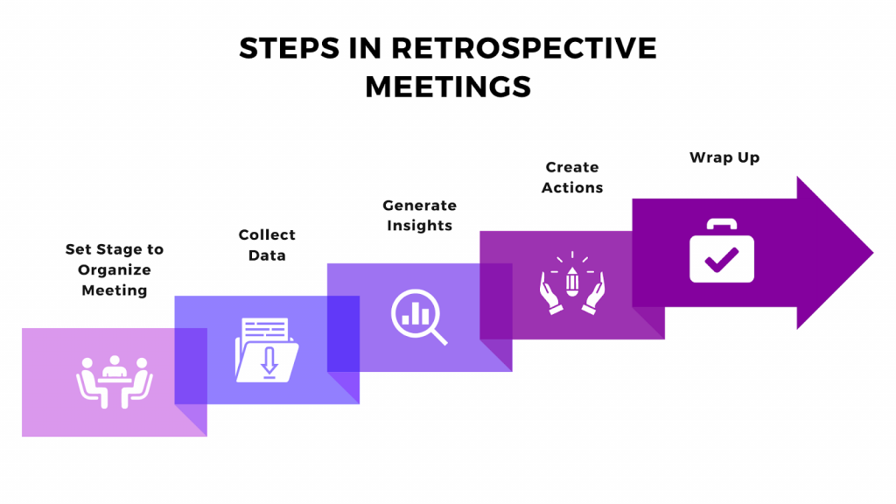

Key Discussion Areas
- What went well?
- What did not go well?
- What can be improved in the next sprint?

Outcomes
- Identified improvement actions
- Enhanced team collaboration
- Better processes in future sprints

Conclusion
Agile meetings play a crucial role in ensuring transparency, adaptability, and continuous improvement. When conducted effectively, they help teams deliver high‑quality software efficiently and collaboratively.

